Blockchain Based E-Commerce Online Application

In existing E-commerce application all customers and product details will be stored and managed in single centralized server and if this server crashed due to too many requests and or if server is hacked then services will not be available to other customers and to overcome from this problem we are migrating E-commerce application to Blockchain which will maintain data at multiple nodes/servers and if one node down then customers can get data from other working nodes. Another advantage of Blockchain has inbuilt support for data encryption and immutable (data cannot be alter by unauthorized users) and it will consider each data as block/transaction and associate each block storage with unique hash code and before storing new records Blockchain will verify hash code of previous blocks and if all nodes blocks verification successful then data is consider as secured.

To implement this project we have used Blockchain Ethereum with Truffle to store E-commerce data and Blockchain cannot store images so we are storing products images inside IPFS (interplanetary file storage) server and this server will store image and returned hash code of stored image and by giving that hash code we can retrieve images from IPFS.

To implement this project we have designed following modules

1. Login: using this module product suppliers and consumers (customers) can login to application
2. Signup: using this module both customers and suppliers can signup with the application to get username and password
3. Add Product: using this module supplier can add new product details with images in Blockchain
4. Update quantity: using this module supplier can update quantity for the product in Blockchain
5. View Orders: using this module supplier can view orders from the customers
6. Browse Products: using this module customers can search product and make an order

We can interact with the Blockchain by using Solidity code so we need to create solidity function for signup users, add products and book orders and then this solidity has to deploy on ethereum Blockchain and by using WEB3 python package we can call this solidity contract. Below is the solidity code

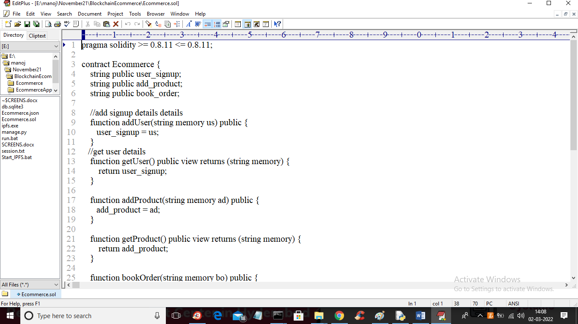

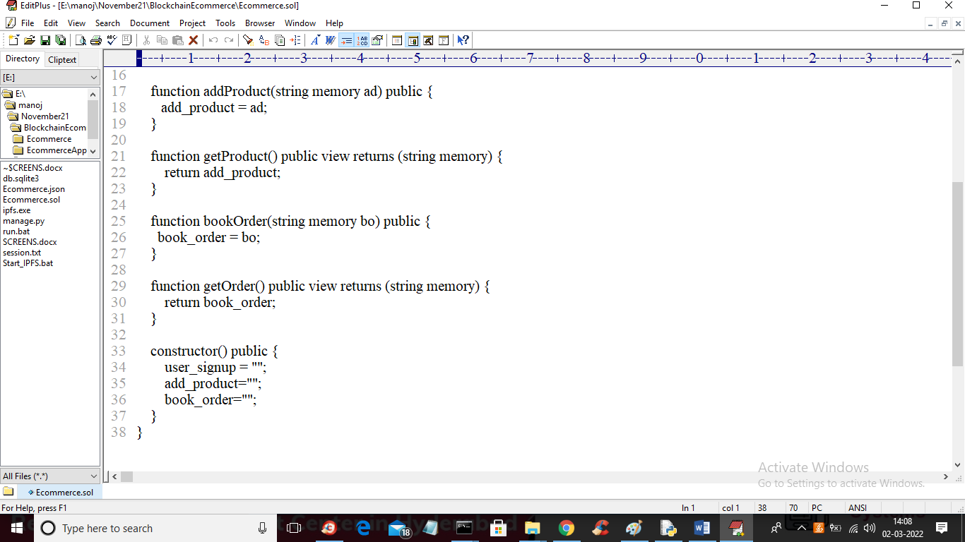

Above solidity code can be deployed in Ethereum by following below instructions

1. Go inside hello-eth/node_modules/.bin folder and double click on runBlockchain.bat file to get below screen

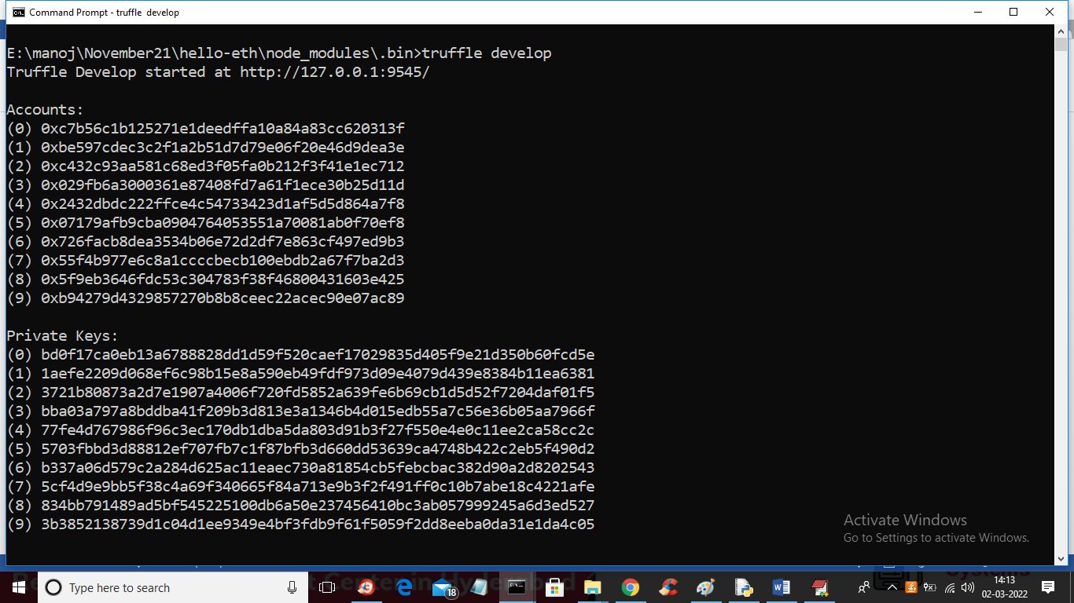

In above screen just type ‘truffle develop’ and press enter key to generate account and private keys and then type ‘truffle migrate’ to deploy solidity contract to Blockchain and get below screen

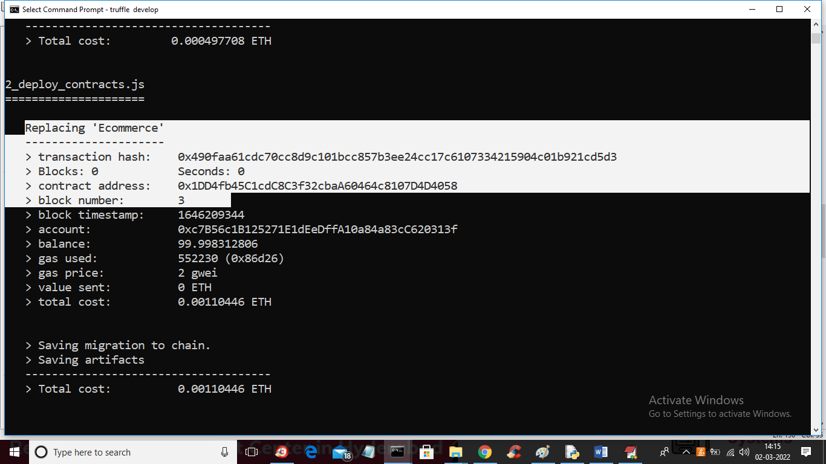

In above screen white selected text you can see that Ecommerce contract deployed and the same contract address we will specify in PYTHON code to access above deployed contract. You can see accessing code in below screen

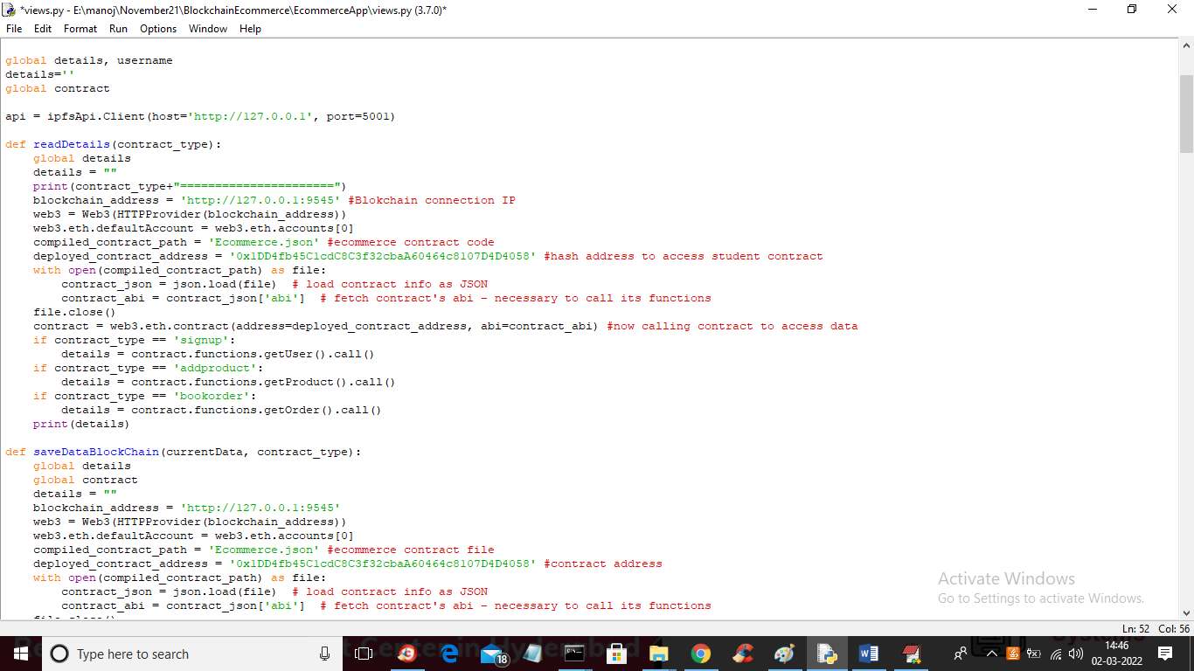

In above screen read red colour comments to know about accessing contract from python to Blockchain. Now double click on ‘Start_IPFS.bat’ file to start IPFS server to get below screen and to start IPFS server

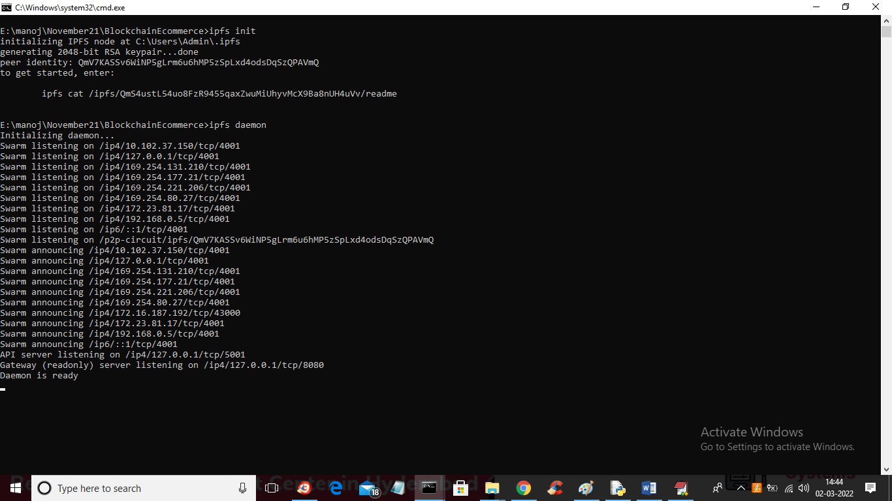

In above screen IPFS server started and now double click on ‘run.bat’ file to start python DJANGO server and to get below screen

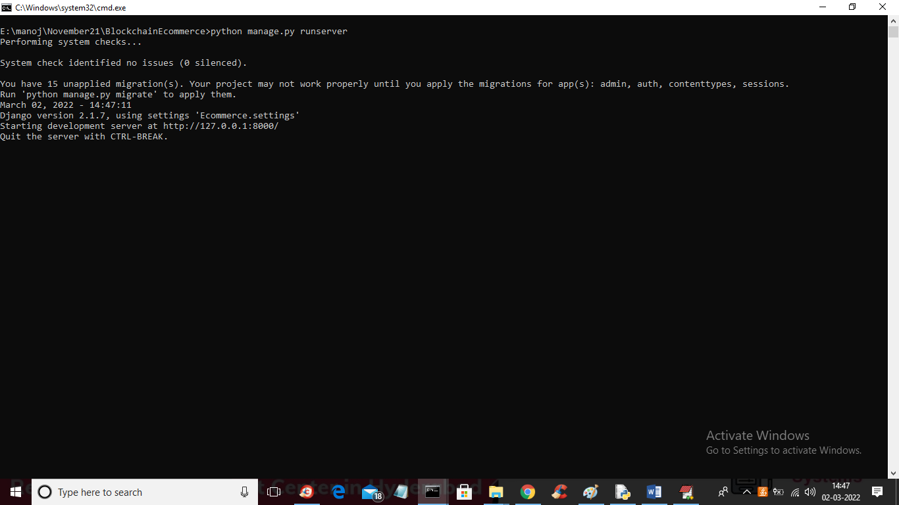

In above screen python DJANGO server started and now open browser and enter URL as ‘http://127.0.0.1:8000/index.html’ and press enter key to get below screen

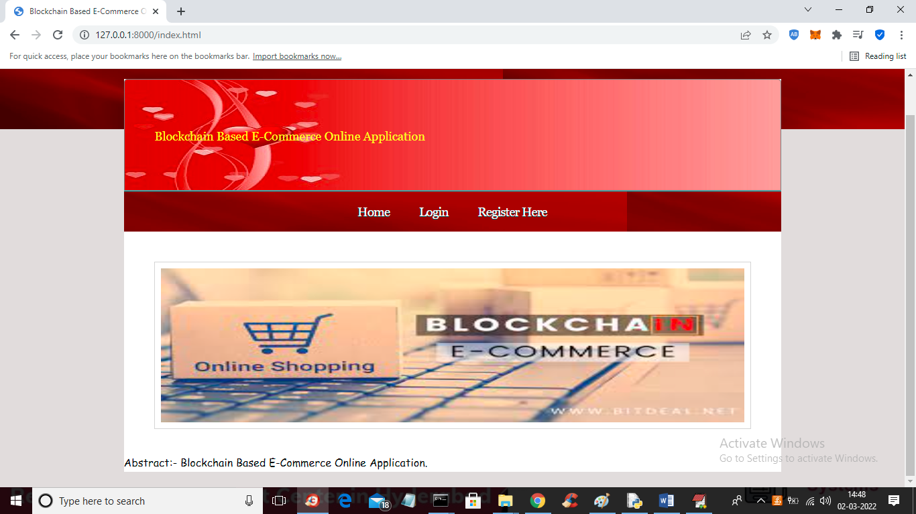

In above screen click on ‘Register Here’ link to signup two users such as consumer and supplier

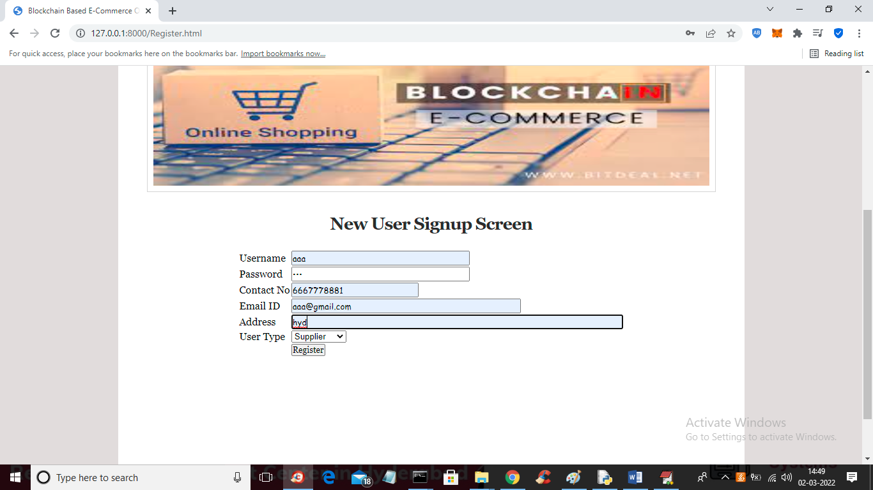

In above screen supplier is getting signup and then press Register button to get below screen

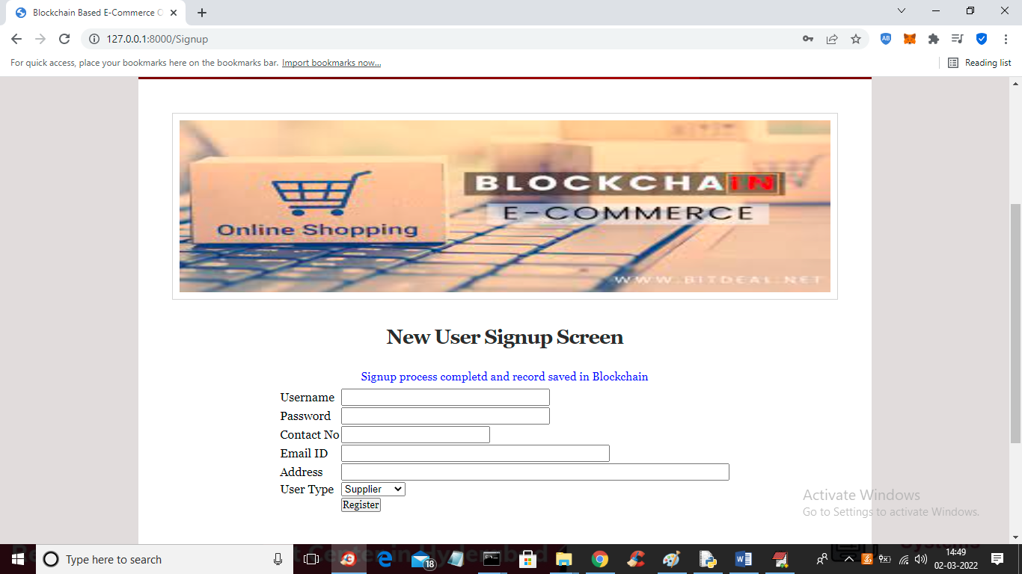

In above screen signup completed and now add consumer user

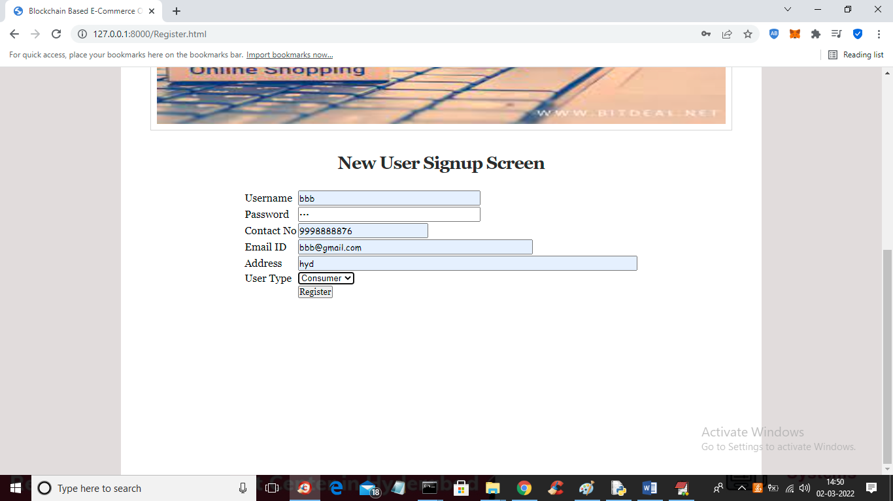

In above screen customer is registering and now click on ‘Login’ link to get below screen

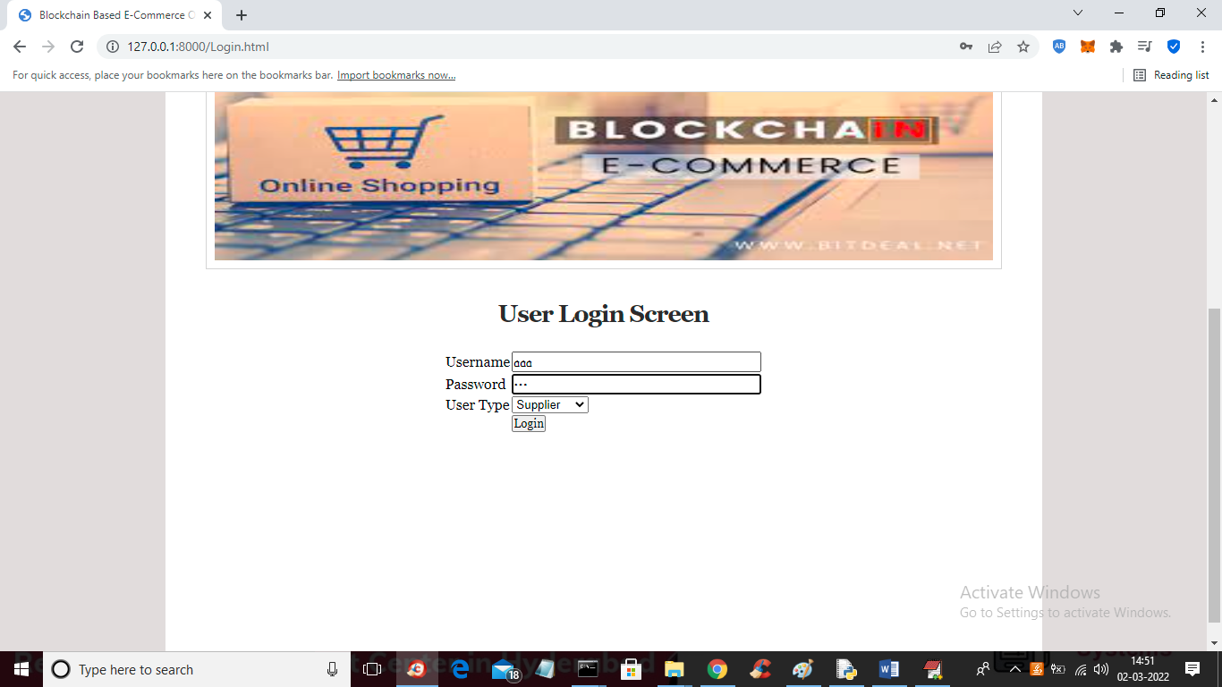

In above screen supplier is login and after login will get below screen

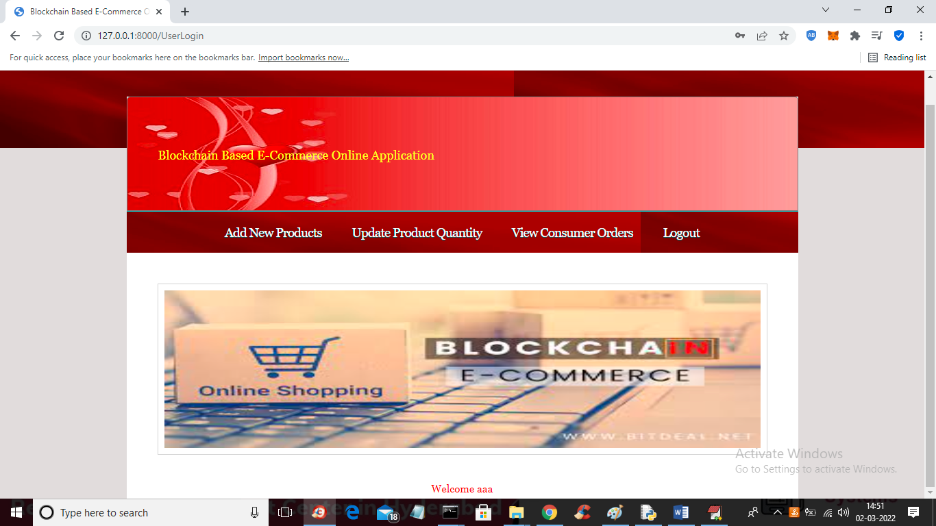

In above screen click on ‘Add New Products’ link to add new product details

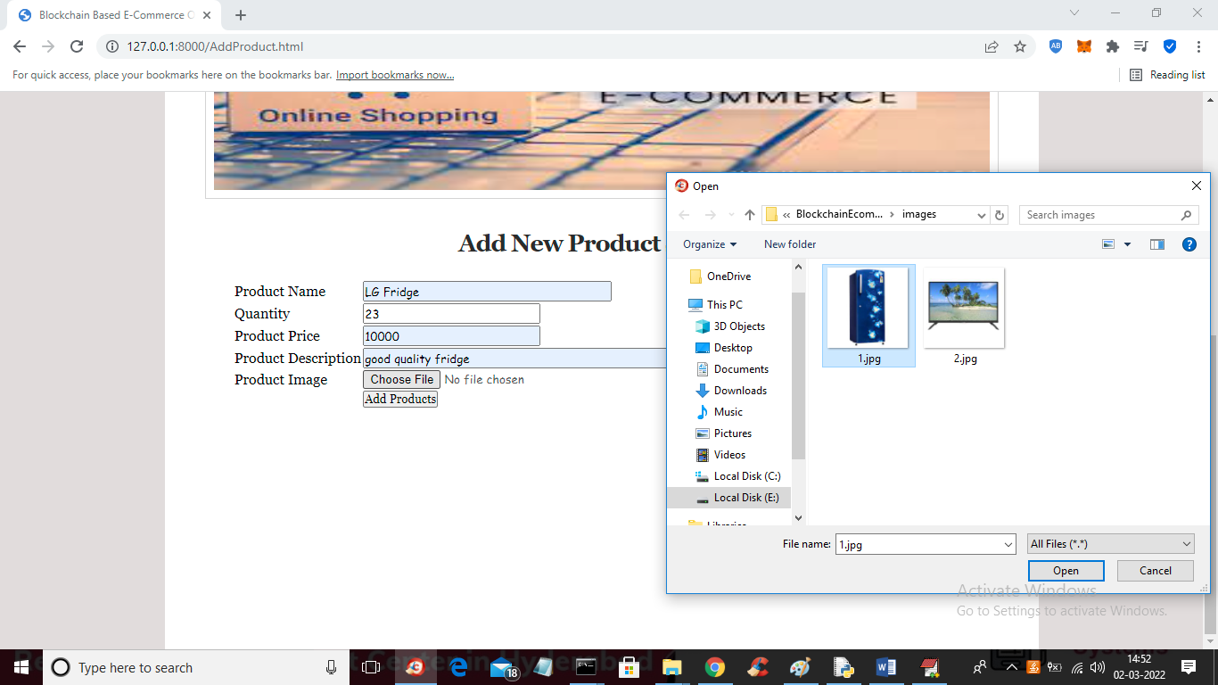

In above screen enter new product details with image and then click on ‘Add Products’ button to add details in Blockchain and get below output

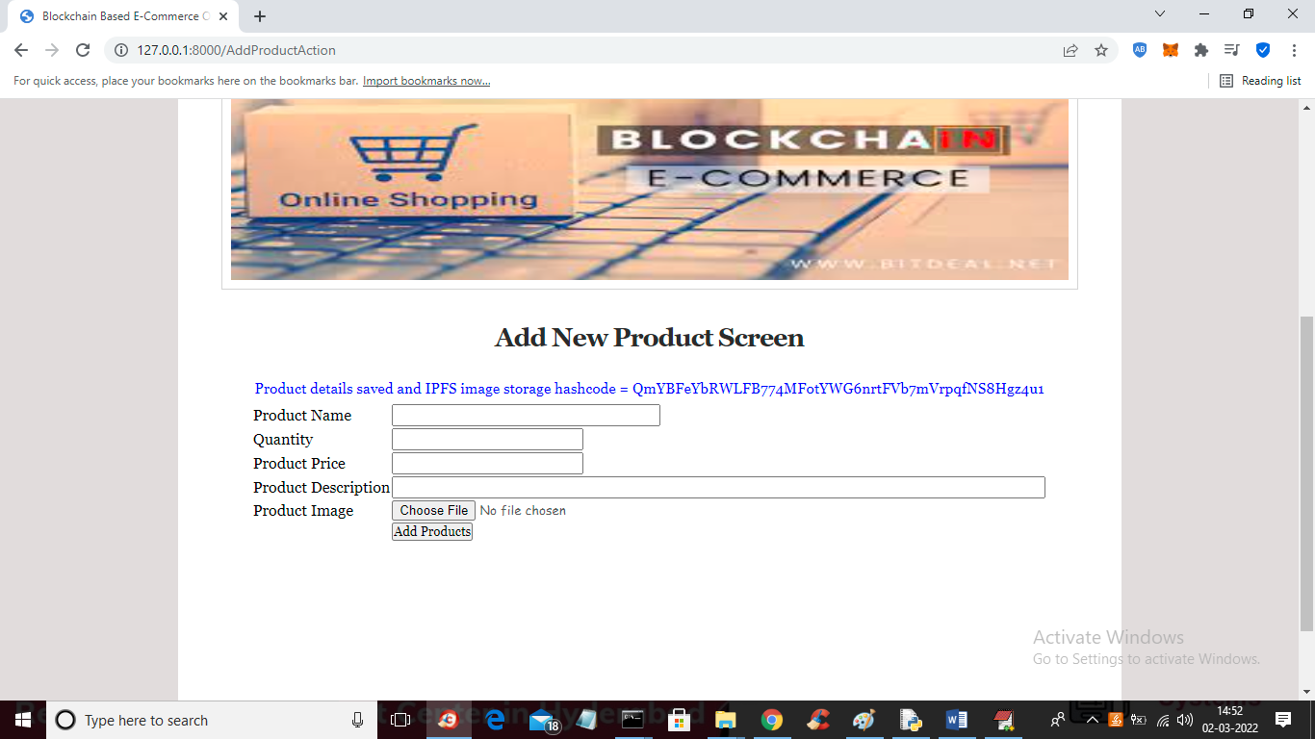

In above screen in blue colour text we can see product details added and we can see hashcode of image where image is stored in IPFS. Similarly you can add any number of projects. Now click on ‘Update Product Quantity’ link to update product quantity

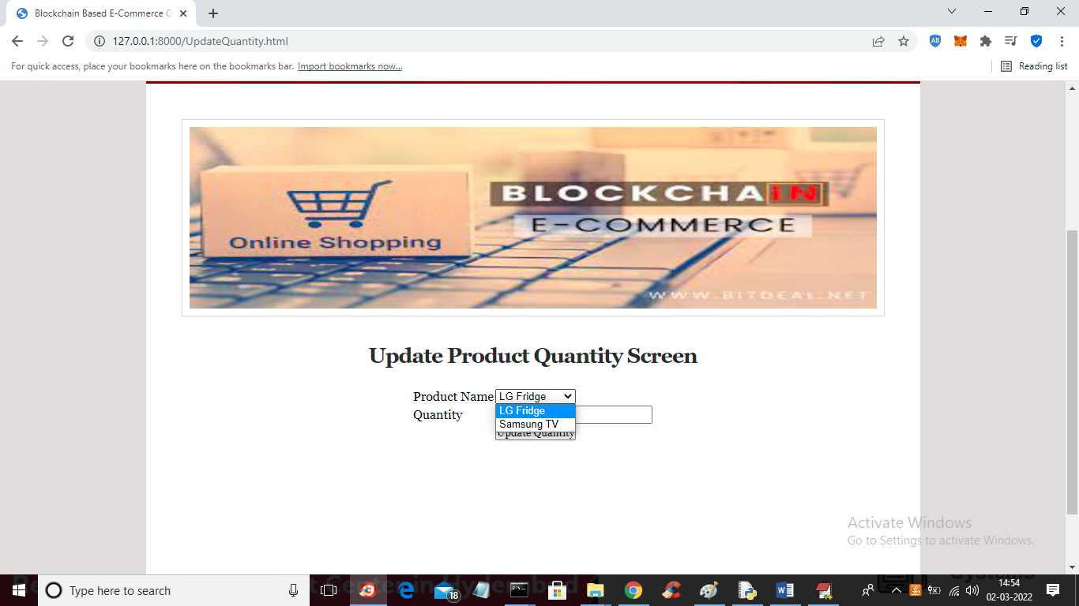

In above screen select any product name and enter new quantity and press button to get below output

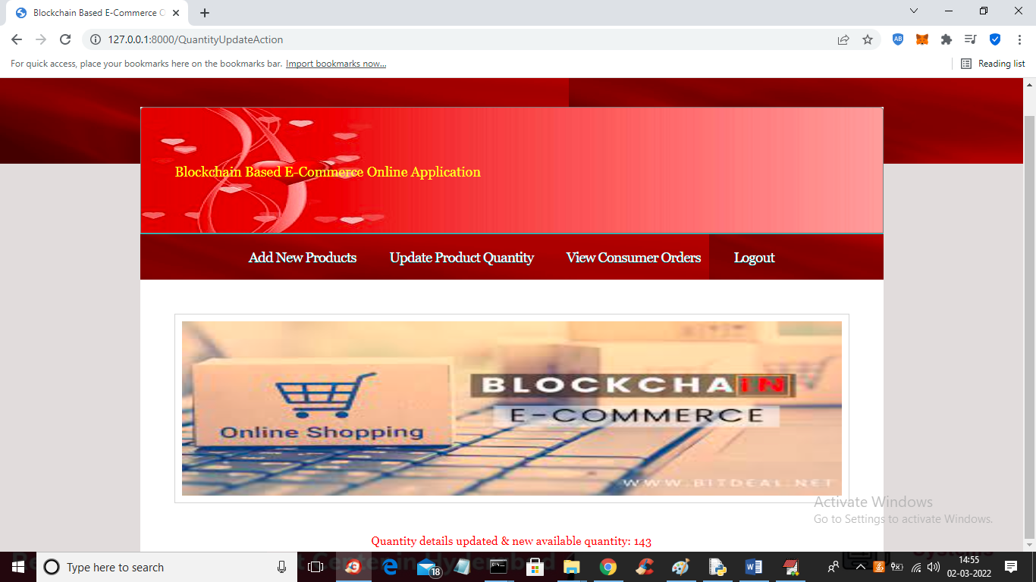

In above screen in red colour we can see quantity is updated and we can see available quantity and now logout and login as customer to purchase products’

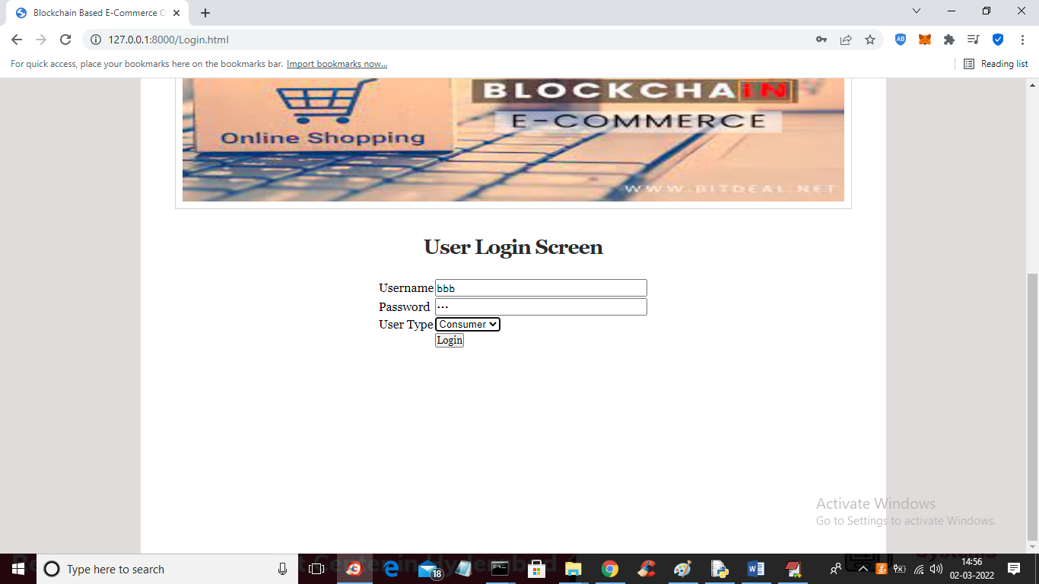

In above screen customer is login and after login will get below screen

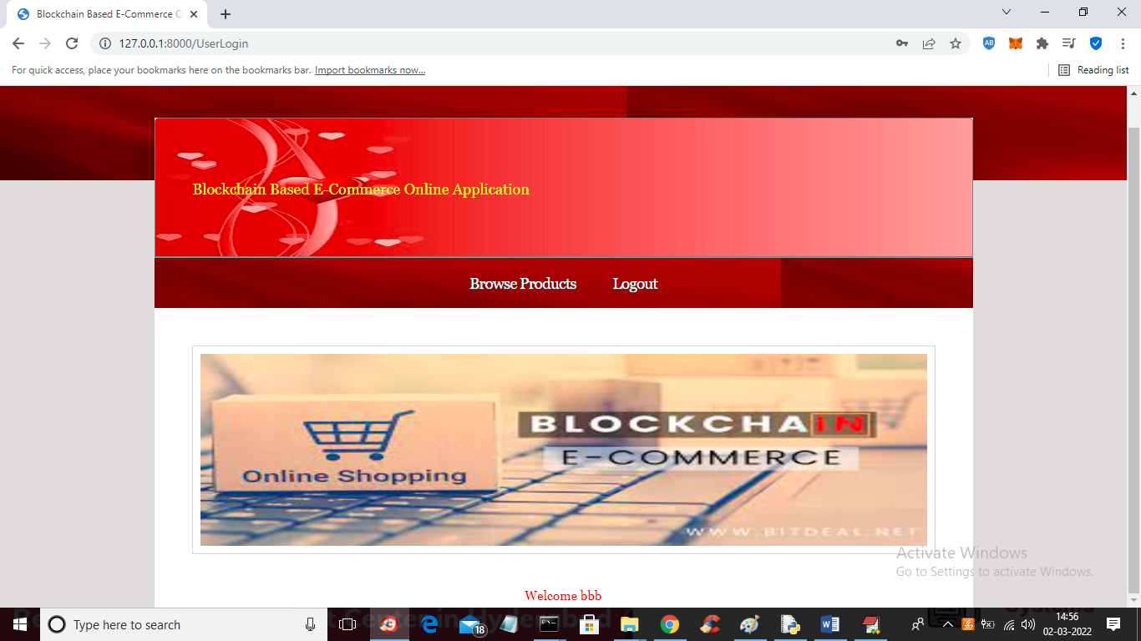

In above screen click on ‘Browse Products’ link to get list of products

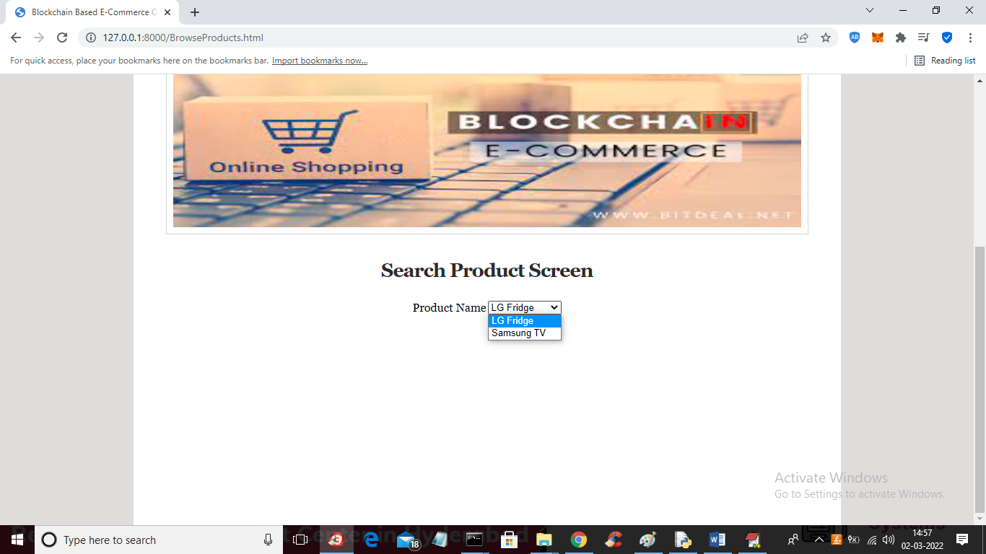

In above screen user can select desired product and press button to get below list of products

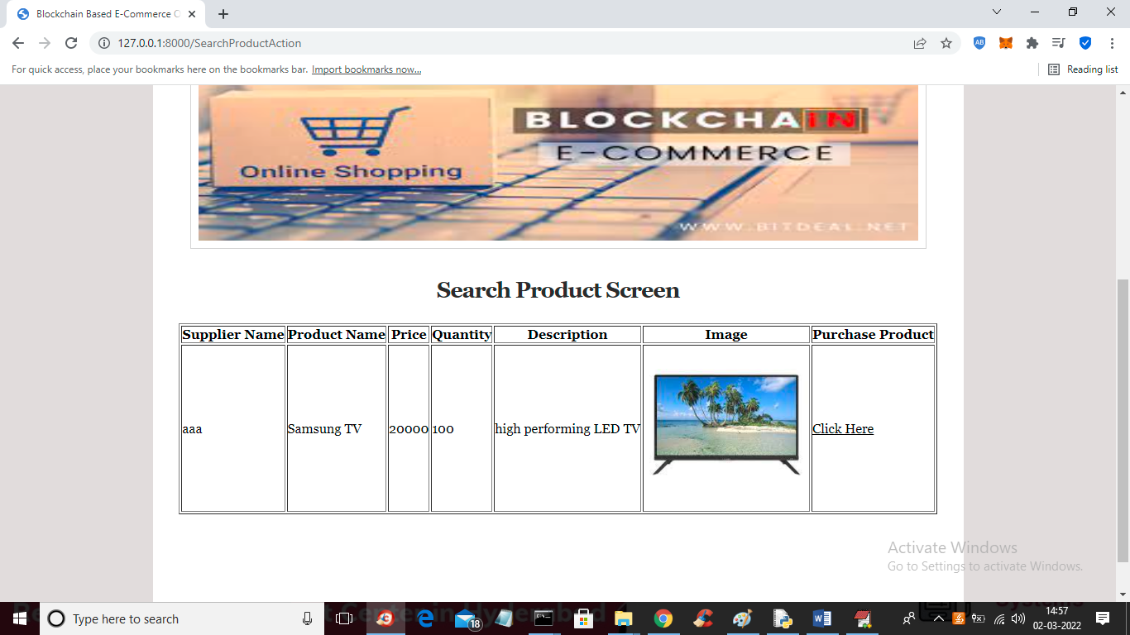

In above screen user can view list of products and then click on ‘Click Here’ link to make an order of this project

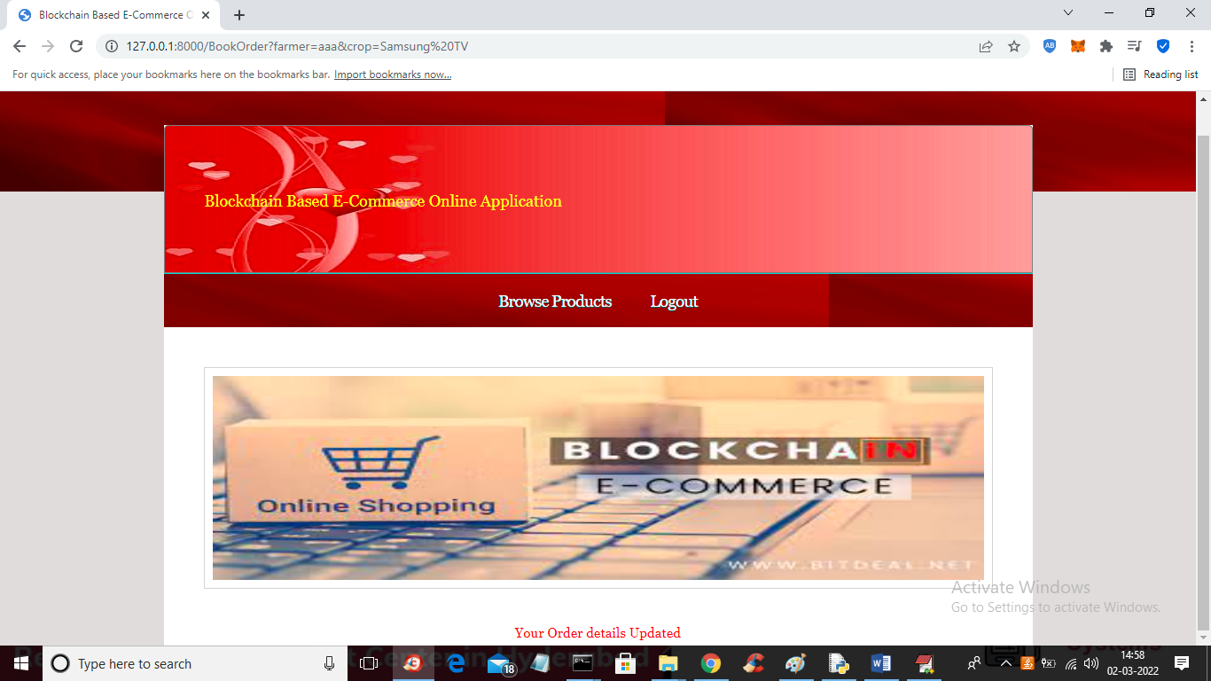

In above screen in red colour text we can see order is updated and now logout and login as supplier to view that order

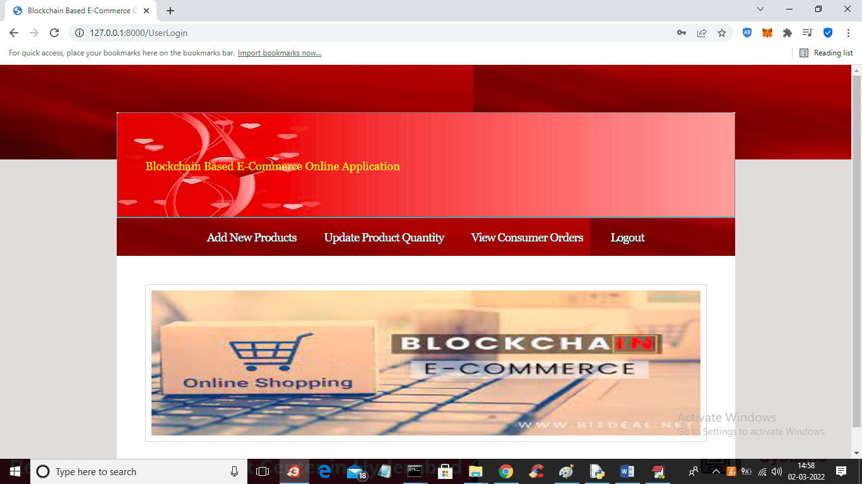

In above screen click on ‘View Consumer Orders’ link to get below order details

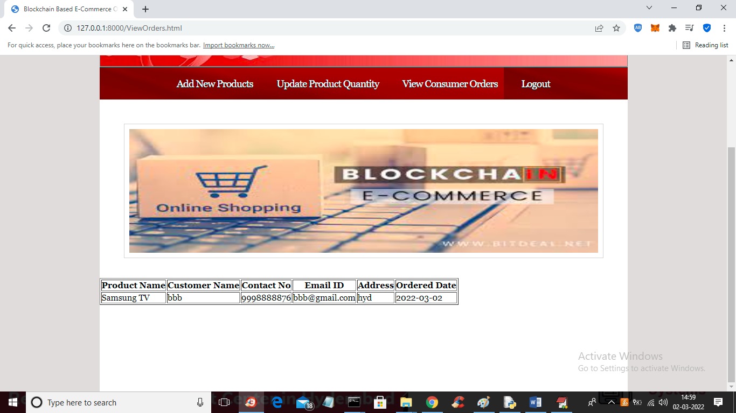

In above screen supplier can see customer contact number and address and complete product delivery

Similarly you can add products and make purchase any number of times